SHEET 3: FOR ME ONLY

F Capital in For
CSR-1 registered NGO

Logo change to

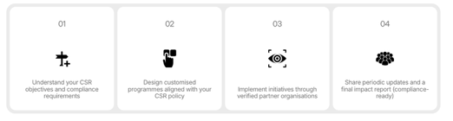
Remove logos from this – write 01 02 03 04 as logo incense in the center
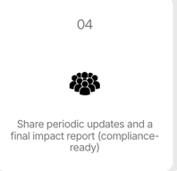
Rewrite Share periodic updates and compliance-ready impact reports – to fit in two lines

Bold – Understand, Design, Implement, Share
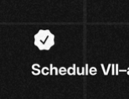
Increase logo size – to make it same as others in this section
Remove "Indicative CSR Budget" field 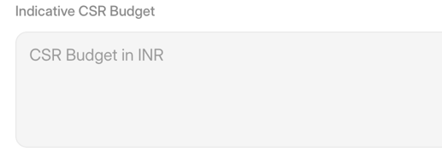
Image & Formatting
Discuss this with me first
1) Left + Right Alignment – Needs to be aligned
2) Font size & font - Needs to be same across the website & which font are you using
3) Padding gaps – needs to be same after each section
4) Image change – need to discuss all website images – need help by creating a bank of images and then placing them
5) old content (hidden) – delete
6) images should be shown full – or should take the pages shape
CTA
I FEEL AT THE START OF THE PAGES – ALL PAGES WE SHOULD HAVE A CTA – EXAMPLE – CSR – CONNECT NOW – IT SHOULD TAKE YOU TO FILL THE FORM PART OF THE PAGE BELOW

